**Nonfiction for Children**

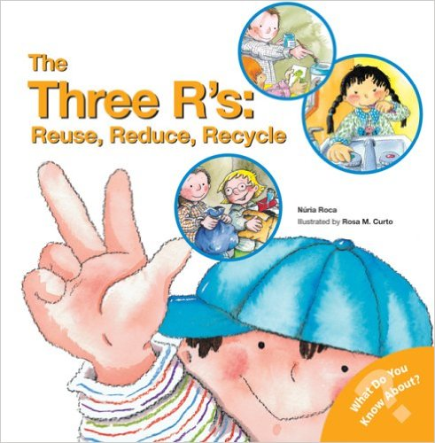

# **[The Three R's: Reuse, Reduce, Recycle (What Do You Know About? Books)](http://www.amazon.com/The-Three-Rs-Reduce-Recycle/dp/0764135813/ref=pd_cp_14_2?ie=UTF8&refRID=1618D2VN993AN4J367NE)**

# February 1, 2007

by [Nuria Roca](http://www.amazon.com/s/ref=dp_byline_sr_book_1?ie=UTF8&field-author=Nuria+Roca&search-alias=books&text=Nuria+Roca&sort=relevancerank) (Author), [Rosa M. Curto](http://www.amazon.com/s/ref=dp_byline_sr_book_2?ie=UTF8&field-author=Rosa+M.+Curto&search-alias=books&text=Rosa+M.+Curto&sort=relevancerank) (Illustrator)

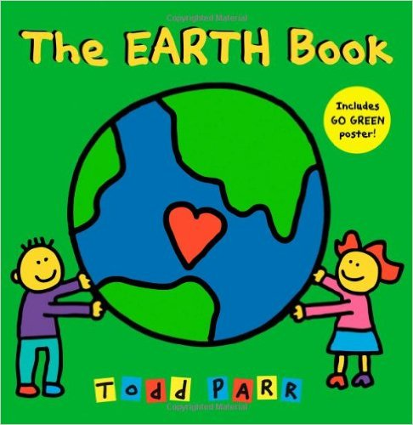

# [**The EARTH Book**](http://www.amazon.com/The-EARTH-Book-Todd-Parr/dp/031604265X/ref=pd_sim_sbs_14_1?ie=UTF8&refRID=07SQ15Q3TKAAFPZQ854G)

# March 17, 2010

by [Todd Parr](http://www.amazon.com/Todd-Parr/e/B001IGR4X6/ref=dp_byline_cont_book_1)  (Author)

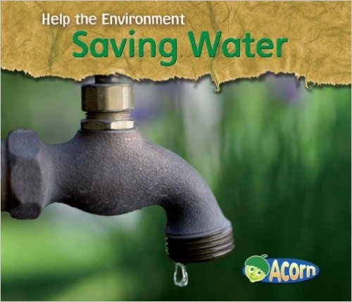

# [**Saving Water (Help the Environment)**](http://www.amazon.com/Saving-Water-Environment-Charlotte-Guillain/dp/1432908928/ref=pd_rhf_dp_s_cp_3?ie=UTF8&refRID=0AHVRCJDNQXR2T9KG9S9)

# January 1, 2008

by [Charlotte Guillain](http://www.amazon.com/Charlotte-Guillain/e/B001JS6YNO/ref=dp_byline_cont_book_1)  (Author)

**Fiction for Children**

**Pre K- K**

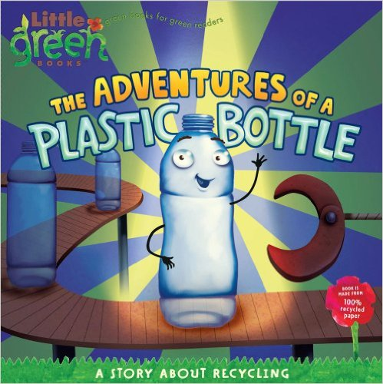

[**The Adventures of a Plastic Bottle: A Story about Recycling (Little Green Books)**](http://www.amazon.com/The-Adventures-Plastic-Bottle-Recycling/dp/1416967885/ref=pd_cp_14_1?ie=UTF8&refRID=1618D2VN993AN4J367NE)

January 6, 2009

by [Alison Inches](http://www.amazon.com/Alison-Inches/e/B000AP86CE/ref=dp_byline_cont_book_1)  (Author), [Pete Whitehead](http://www.amazon.com/s/ref=dp_byline_sr_book_2?ie=UTF8&field-author=Pete+Whitehead&search-alias=books&text=Pete+Whitehead&sort=relevancerank) (Illustrator)

[Alison Inches](http://www.amazon.com/Alison-Inches/e/B000AP86CE/ref=pd_cp_14_bl_1?_encoding=UTF8&refRID=1618D2VN993AN4J367NE)

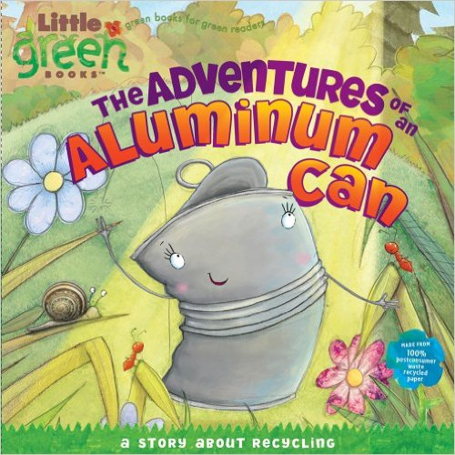

# [**The Adventures of an Aluminum Can: A Story about Recycling (Little Green Books)**](http://www.amazon.com/The-Adventures-Aluminum-Can-Recycling/dp/1416972218/ref=pd_bxgy_14_img_z)

# May 5, 2009

by [Alison Inches](http://www.amazon.com/Alison-Inches/e/B000AP86CE/ref=dp_byline_cont_book_1)  (Author), [Mark Chambers](http://www.amazon.com/s/ref=dp_byline_sr_book_2?ie=UTF8&field-author=Mark+Chambers&search-alias=books&text=Mark+Chambers&sort=relevancerank) (Illustrator)

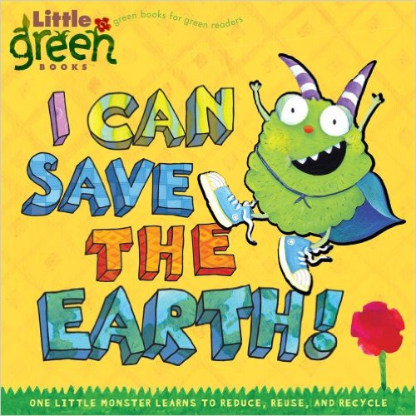

# [**I Can Save the Earth!: One Little Monster Learns to Reduce, Reuse, and Recycle**](http://www.amazon.com/Can-Save-Earth-Monster-Recycle/dp/1416967893/ref=pd_bxgy_14_img_z) (Little Green Books)

# September 9, 2008

by [Alison Inches](http://www.amazon.com/Alison-Inches/e/B000AP86CE/ref=dp_byline_cont_book_1)  (Author), [Viviana Garofoli](http://www.amazon.com/s/ref=dp_byline_sr_book_2?ie=UTF8&field-author=Viviana+Garofoli&search-alias=books&text=Viviana+Garofoli&sort=relevancerank) (Illustrator)

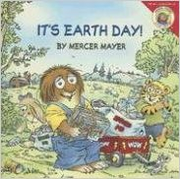

# [**It's Earth Day!**](http://www.amazon.com/Its-Earth-Day-Little-Critter/dp/0060539593/ref=pd_cp_14_4?ie=UTF8&refRID=19Z941RP237BNNNFTXBW) (Little Critter)

# February 26, 2008

by [Mercer Mayer](http://www.amazon.com/Mercer-Mayer/e/B004N1UI0Y/ref=dp_byline_cont_book_1)  (Author)

**K-Primary**

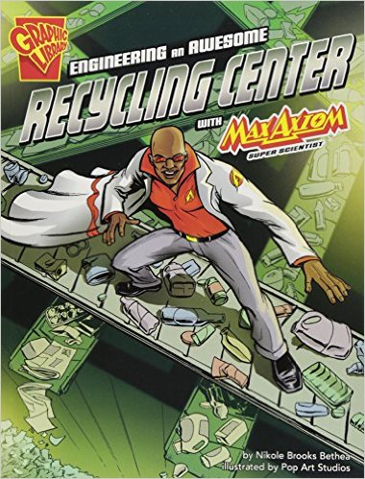

**[Engineering an Awesome Recycling Center With Max Axiom, Super Scientist (Graphic Science and Engineering in Action)](http://www.amazon.com/Engineering-Awesome-Recycling-Scientist-Graphic/dp/162065699X/ref=sr_1_22?s=books&ie=UTF8&qid=1436202682&sr=1-22&keywords=recycling" \o "Engineering an Awesome Recycling Center With Max Axiom, Super Scientist (Graphic Science and Engineering in Action))**

Jan 2013

by [Nikole Brooks Bethea](http://www.amazon.com/Nikole-Brooks-Bethea/e/B004D1OU3U/ref=sr_ntt_srch_lnk_22?qid=1436202682&sr=1-22) and Pop Art Studios

# [**Recycling Day**](http://www.amazon.com/The-EARTH-Book-Todd-Parr/dp/031604265X/ref=pd_sim_sbs_14_1?ie=UTF8&refRID=07SQ15Q3TKAAFPZQ854G)

# July 1, 2015

by [Edward Miller](http://www.amazon.com/s/ref=dp_byline_sr_book_1?ie=UTF8&field-author=Edward+Miller&search-alias=books&text=Edward+Miller&sort=relevancerank) (Author)

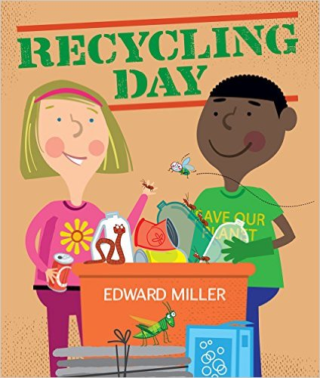

**Resources for Teachers**

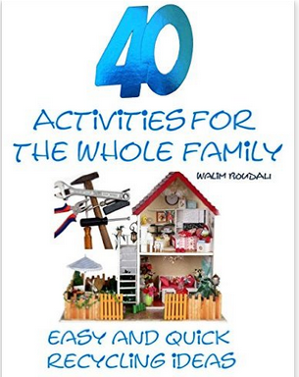

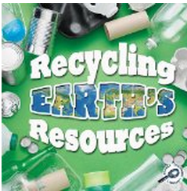

**[Recycling Earth's Resources (Green Earth Discovery Library)](http://www.amazon.com/Recycling-Earths-Resources-Discovery-Library/dp/1615905383/ref=sr_1_18?s=books&ie=UTF8&qid=1436202682&sr=1-18&keywords=recycling" \o "Recycling Earth's Resources (Green Earth Discovery Library))**

Sep 9, 2011

by [Barbara L. Webb](http://www.amazon.com/Barbara-L.-Webb/e/B003E0YWI4/ref=sr_ntt_srch_lnk_18?qid=1436202682&sr=1-18)